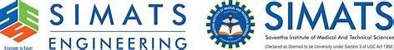

Name:S.karnesh
Reg.No:192421200
Course code:CSA1257
Course Name: COMPUTER ARCHITECTURE
MICROPROCESSOR 8085-16 BIT

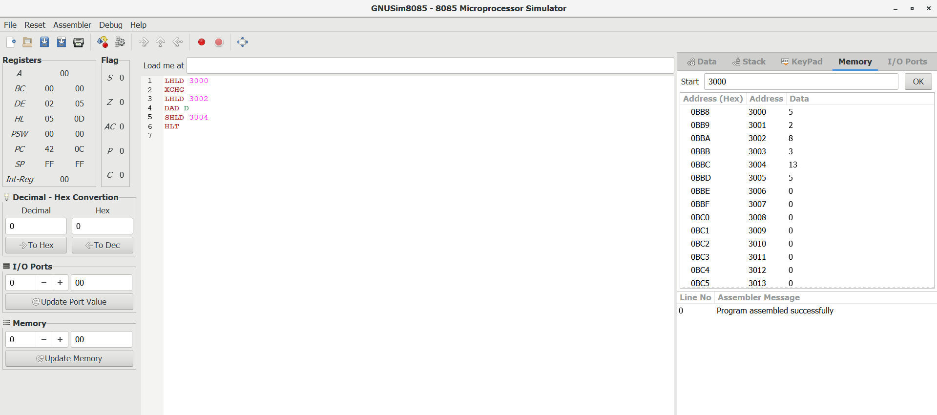
1.ADDITION
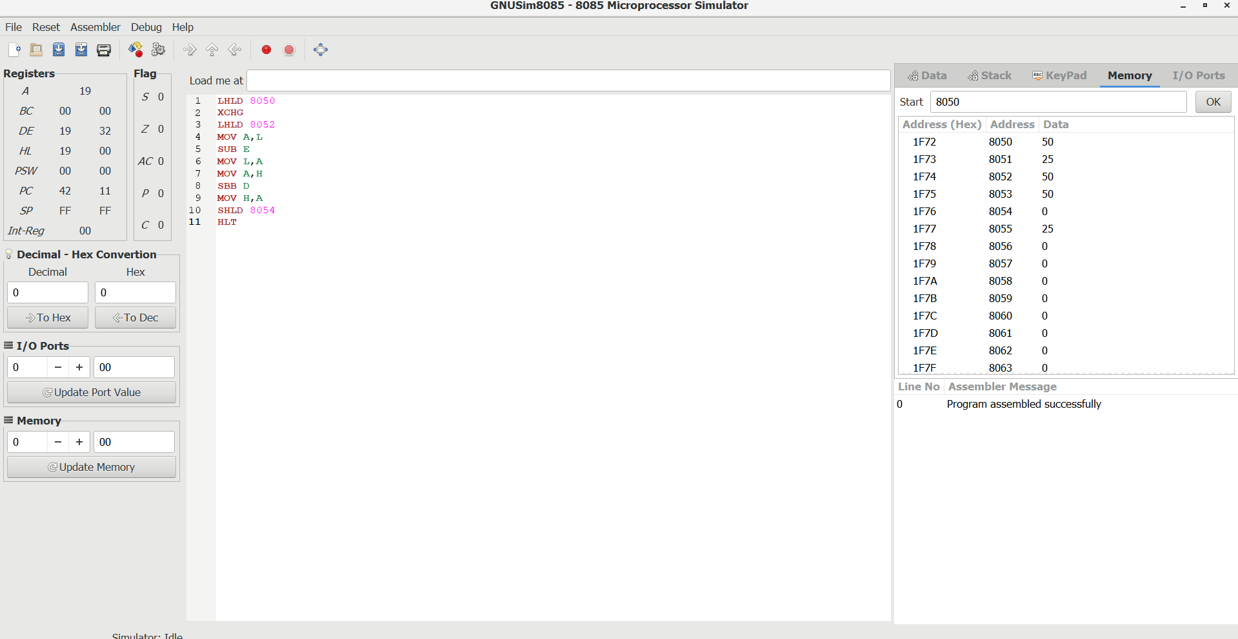
2.SUBTRACTION

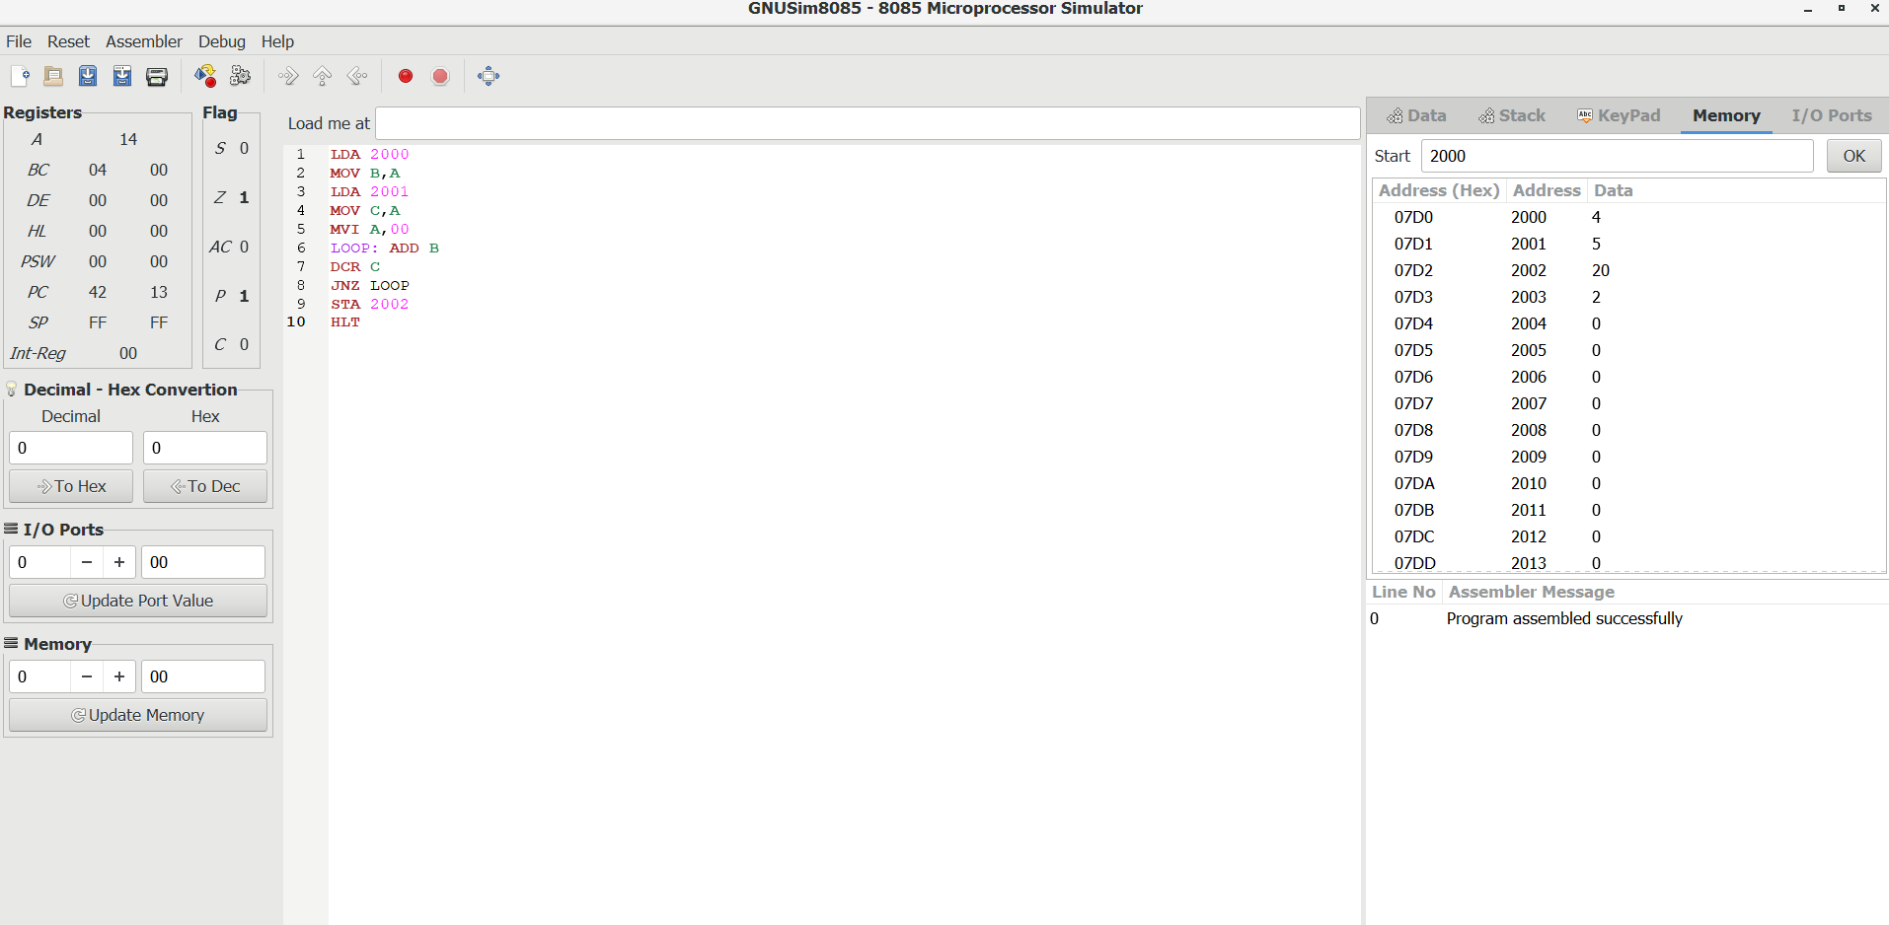
3.MULTIPLICATION

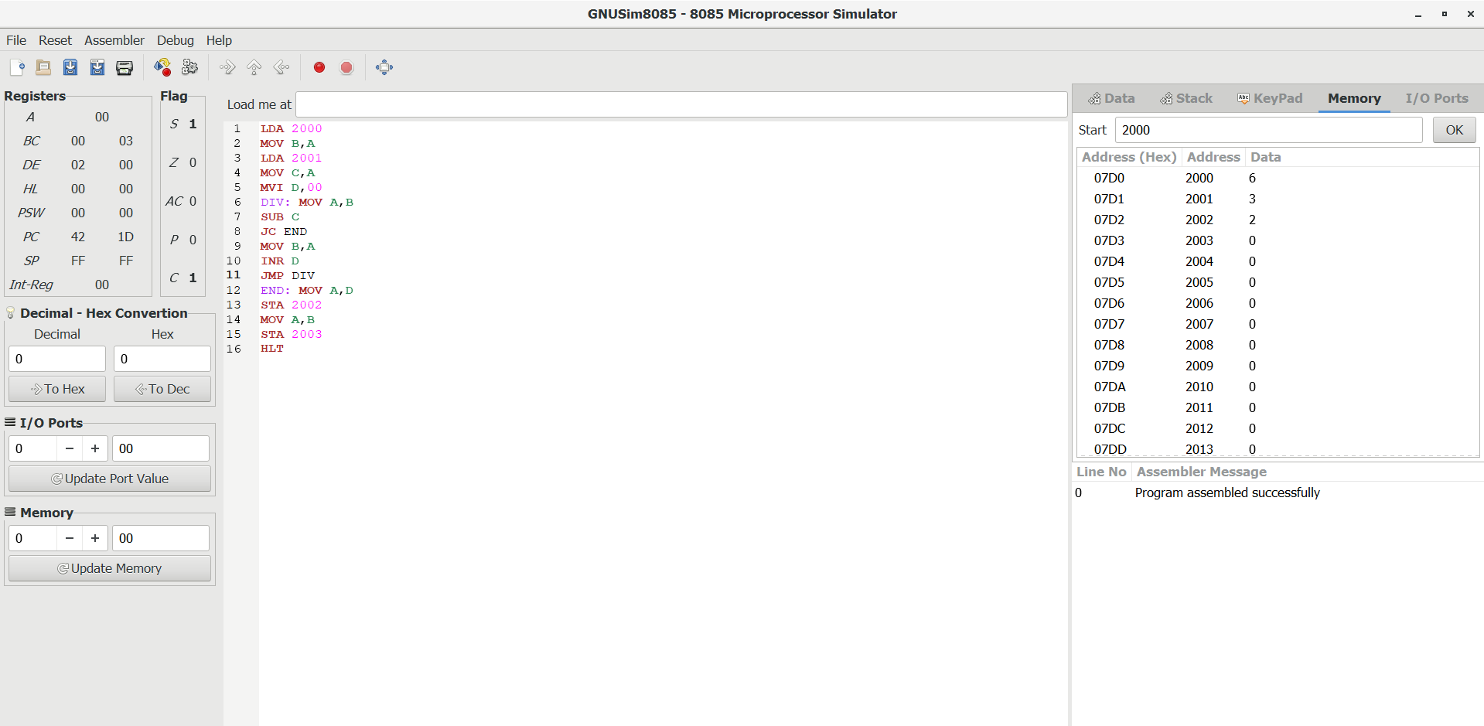
4.DIVISION

